Lab Assignment-3
School of Engineering and Technology
Course Name & Code: Operating System Lab ENCA252



BCA(AI & DS)-B
(2025–2026)

Prepared by:- Submitted to
Sohail khan Dr.Jyoti Yadav
2401201080

Task 1: Input and Page Reference String Objective: To understand page request handling.
Description:
Students will input:
• Number of frames • Page reference string
Sub-Tasks:
- Input number of frames
- Input page sequence 3. Display reference string Expected Outcome:
- Understanding of paging system
- Ability to simulate memory reference
Task1 Code:-
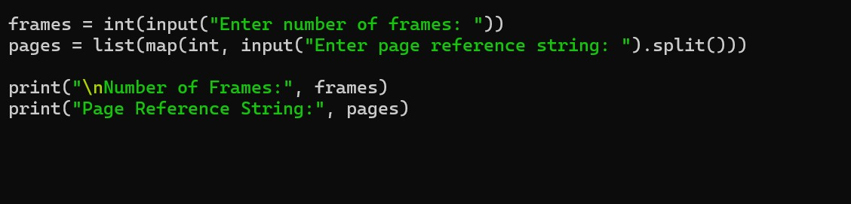
Task 1 Output:-
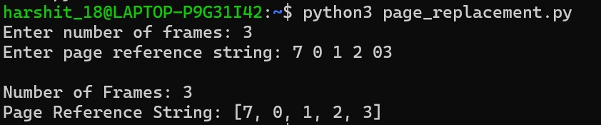

Task 2: FIFO (First-In-First-Out) Objective:
To implement FIFO algorithm.
Description:
Oldest page is replaced first.
Sub-Tasks:
- Maintain queue of pages
- Replace oldest page
- Count page faults
Expected Outcome:
- Understanding simple replacement
- Page fault calculation
Task2 code:-
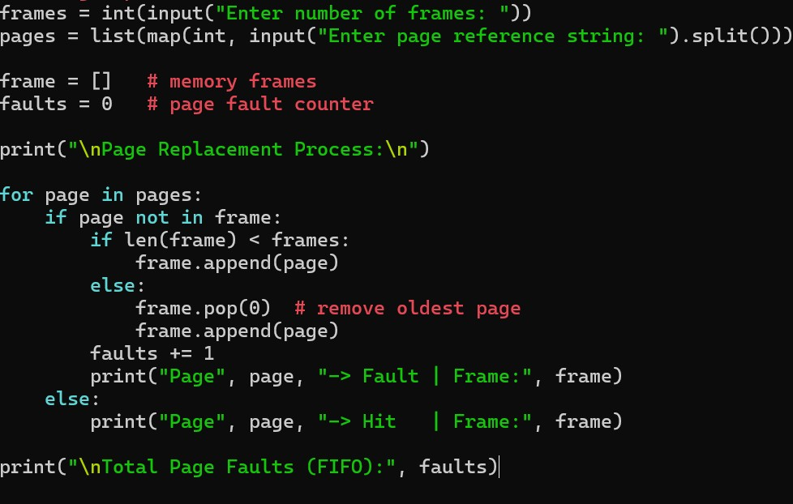
Task 2 Output:-
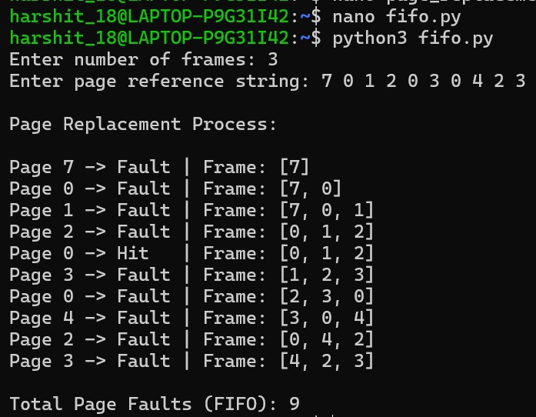

Task 3: LRU (Least Recently Used) Objective:
To implement LRU algorithm.
Description:
Least recently used page is replaced.
Sub-Tasks:
- Track usage history
- Replace least recently used page
- Count faults
Expected Outcome:
- Understanding temporal locality
- Efficient page tracking
Task 3 Code:-
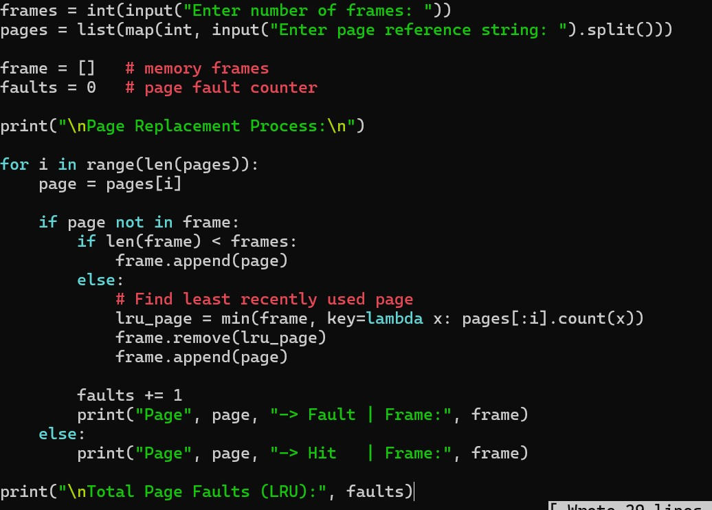
Task 3 Output:-
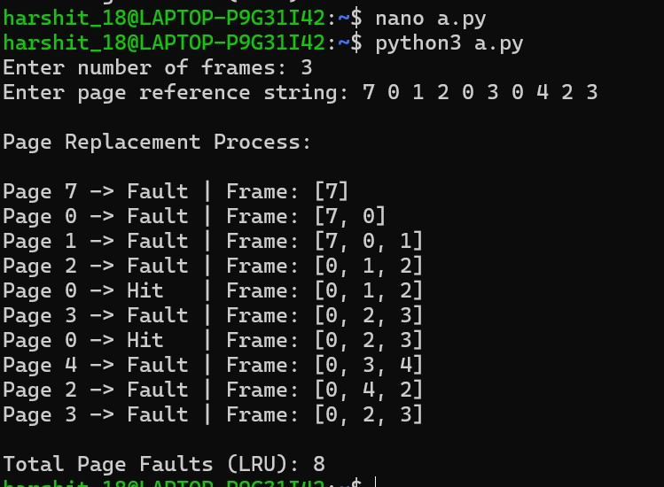
** Task 4: Optimal Page Replacement Objective:
To implement Optimal algorithm.
Description:
Replaces page that will not be used for longest time in future.
Sub-Tasks:
- Look ahead in reference string
- Select page with farthest future use
- Count page faults
Expected Outcome:
- Minimum page faults
- Benchmark comparison
Task 4 code:-
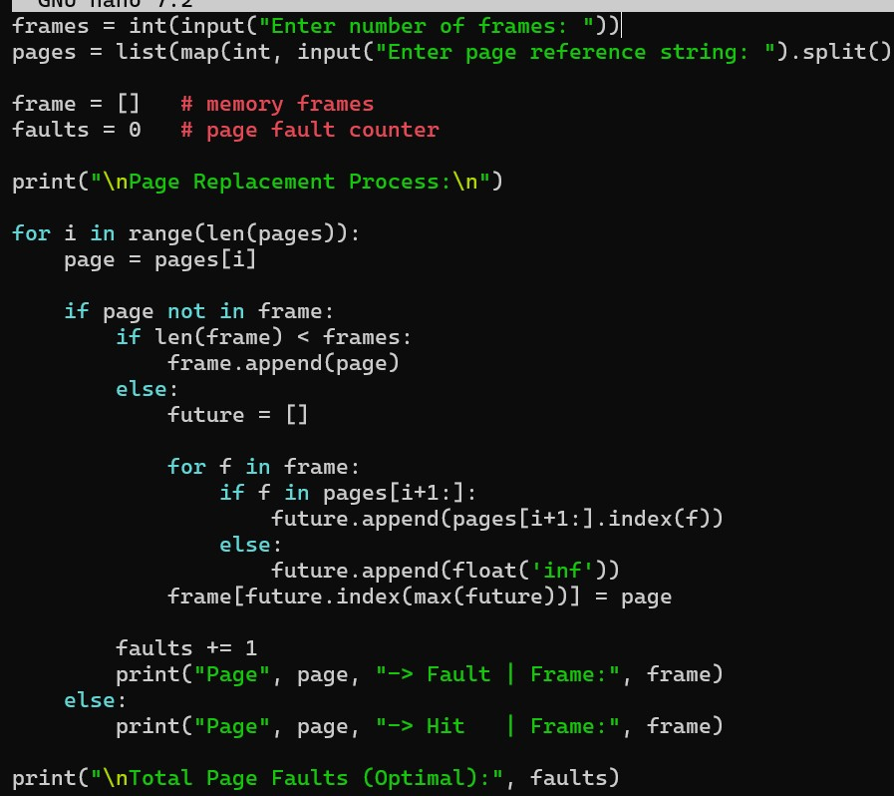
Task 4 Output:-
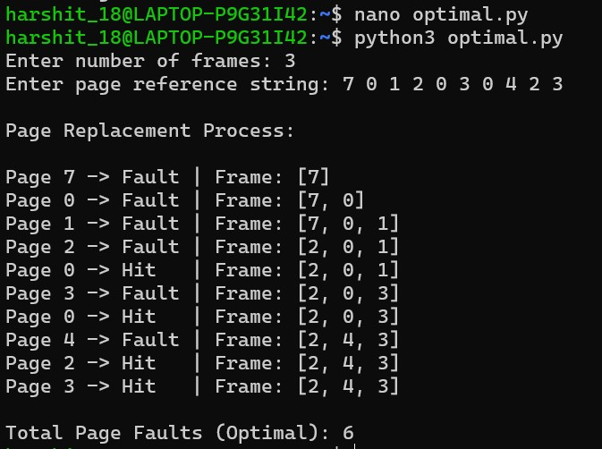
** Task 5: MRU (Most Recently Used) Objective:
To implement MRU algorithm.
Description:
Most recently used page is replaced.
Sub-Tasks:
- Track recent pages
- Replace most recently used
- Count faults
Expected Outcome:
- Understanding reverse locality
- Special-case performance analysis
Task 5 code:-
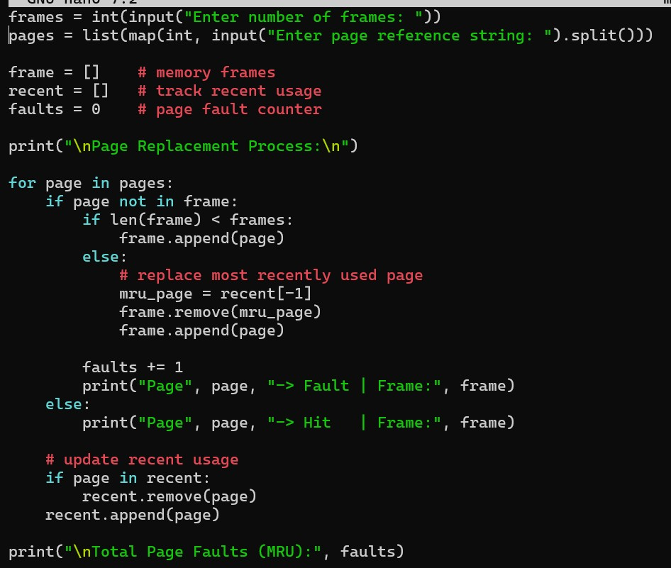
Task 5 Output:-
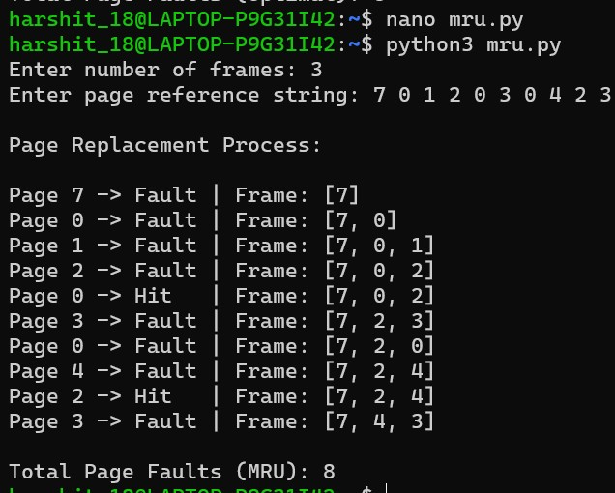
** Task 6: Performance Comparison Objective:
To compare all algorithms.
Description:
Students will compare:
- Total page faults
- Efficiency
Sub-Tasks:
- Execute all algorithms
- Compare page faults 3. Identify best algorithm Expected Outcome:
- Analytical understanding
- Performance comparison
Task 6 code:-
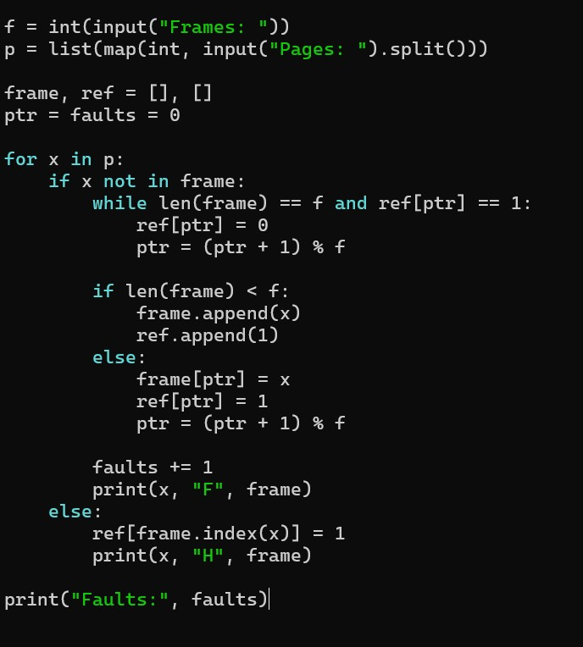
Task 6 Output:-
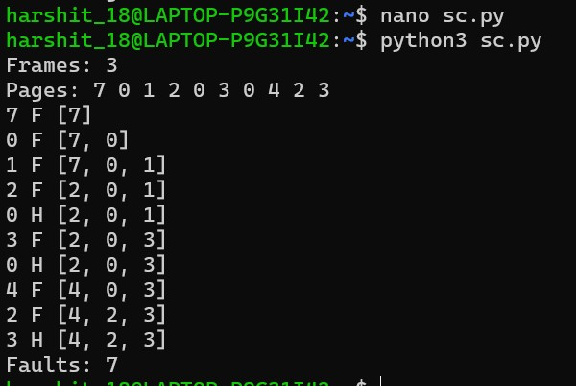

** Task 7: Result Analysis Objective:
To interpret results.
Description:
Students will:
- Identify best and worst algorithms
- Justify results
Sub-Tasks:
- Compare outputs
- Analyze pros/cons
- Write conclusion
Expected Outcome:
- Concept clarity
- Real-world understanding
Task 7 code:-
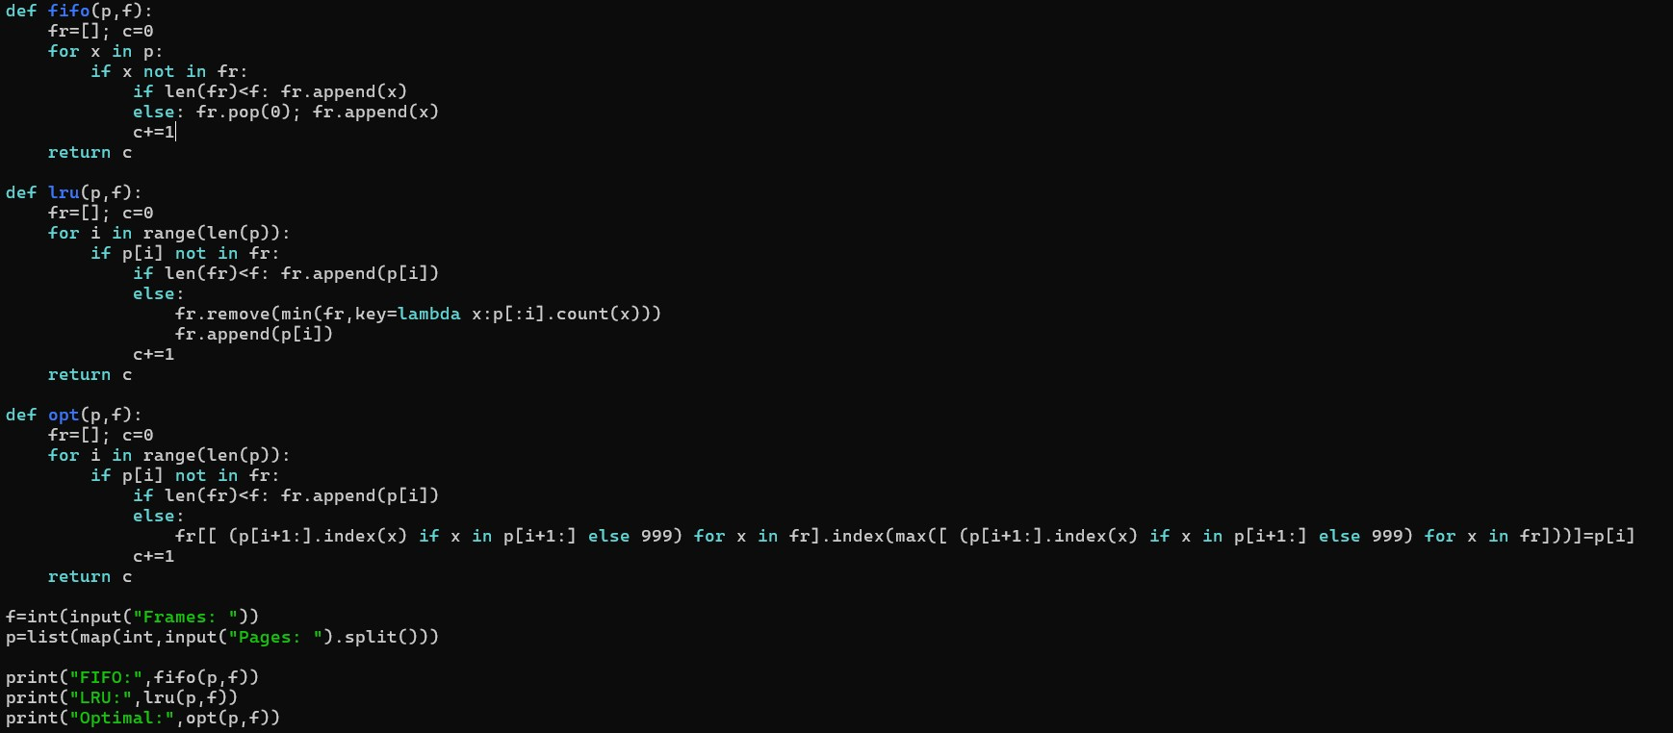
Task 7 Output:-
